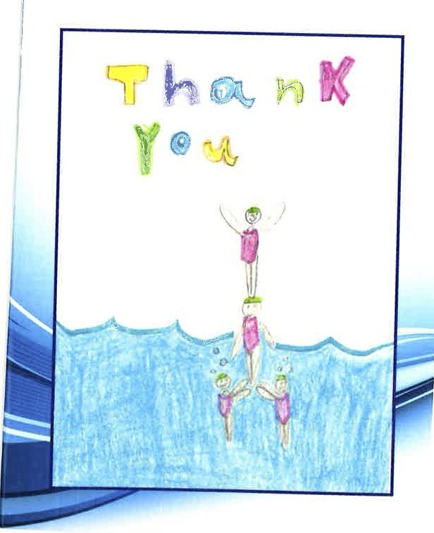
#2
#1
Synchronized Swimming
Thank You Cards
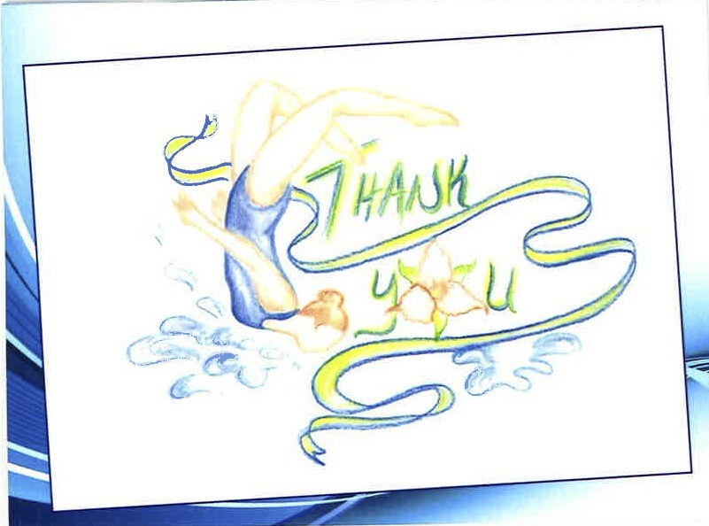
#5

#4

#3

Blank Options

#7
#6
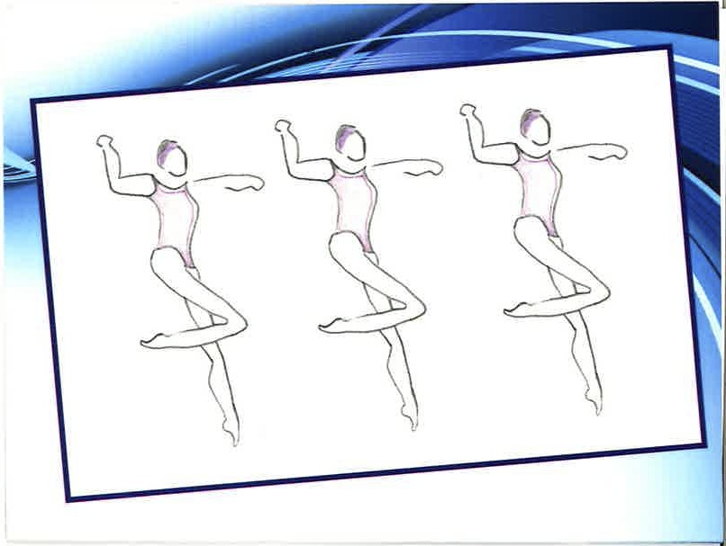

Package Price List

Mixed card packages | Cost | Custom Order  Single design option | Card # | Cost
21 cards – 3 of each design | $17.50 | 21 cards |  | $20.00
42 cards – 6 of each design | $32.00 | 42 cards |  | $35.00
100 cards –14 ea. of the 5 thank you cards  15 ea. of the 2 blank cards | $65.00 | 100 cards |  | $68.00
To Order please complete SSO merchandise order form
*** For orders over 100 cards please contact Synchro Swim Ontario directly***

Club Name:_________________________ Email address:____________________________________

