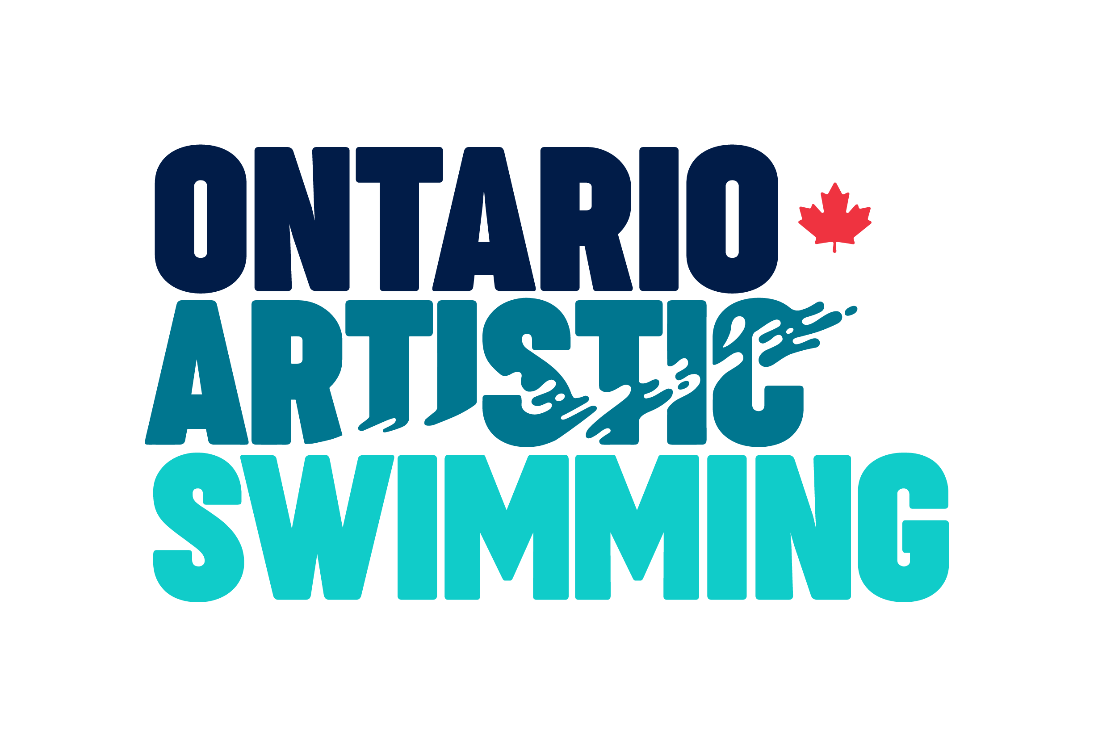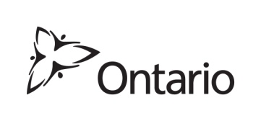
Ontario Artistic Swimming
Quest for Gold – Ontario Athlete Assistance Program 2018-2019
ATHLETE SELECTION APPLICATION
Revised as of January 17, 2019

Applicant Name:
Full Address:
Email:
Phone Number:

Please submit full and complete responses to the following questions:

- Please describe your personal performance targets that align with the overarching goal of “Quest for Gold” – “improving the performance and number of Ontario athletes performing at the national and international level, thereby contributing to the improved performance of Canada at international competitions.”

- Please specifically outline your individualized training plan for the 2018-19 season as per the Ontario Artistic Swimming Sport Specific Selection Criteria #4 at either the daily training environment (DTE) of the Regional Training Centre – Ontario (RTC-ON), OR at a registered Competitive Ontario Member Club. This should include training hours per week (land/water), strength training, extra routines, training camps, planned competitions, etc.

- Please state as per the Ontario Artistic Swimming Sport Specific Selection Criteria #5 “Order of Card Allotments” how you qualify for nomination for Ontario card status under either A) - Full Card Eligibility, or B) - Half Card Eligibility.

- Please outline the expenses that your Quest for Gold funding would be applied towards (as per the Quest for Gold Ontario Athlete Assistance Program Overview):

What are the eligible expenses that a carded athlete can spend funding on obtained through the Quest for Gold - Ontario Athlete Assistance Program?
Carded athletes receiving funding under the Ontario Athlete Assistance Program can spend funding obtained only on the following items:
- Normal living costs;
- Costs directly associated with training (e.g. coaching, facility fees, other athlete services);
- Costs associated with attending training camps and competitions (e.g. entry fees, travel costs);
- Sport-specific equipment; and
- Tuition and education related expenses (e.g. books, fees, commuting costs).

Please be specific (list item and approximate amount) and provide as much detail as possible.

Example:
Club Registration Fees - $5000
Travel Costs to National Qualifier - $500
Etc.

- As per the Ministry of Tourism, Culture and Sport Eligibility Criteria, “If eligible, the athlete must compete, and continue to compete solely for Ontario and/or Canada for one year from the date of the Minister’s letter informing the athlete of acceptance into OAAP program, at Canada Games and other national competitions involving provincial team competitions”, please confirm your intent to compete for the 2019-2020 season in accordance with these guidelines, stating the specific age group you will be competing in and your goals for the 2019-2020 season including competitions you intend to compete at. In addition, please confirm your intent to reach Canada Artistic Swimming’s National Team level in the future, and how you will achieve this goal.

I have read, understand and acknowledge the Quest for Gold – Ontario Athlete Assistance Program and Ontario Artistic Swimming Athlete Selection Criteria, and hereby submit my application in accordance with the posted criteria.

Name: ______________________________________________

Signature: ___________________________________________

Date: _______________________________________________

To Apply:
Rankings will only be compiled by the Selection Committee for athletes that submit an Athlete Selection
Application Form as outlined below.

All required information as on the Ontario Artistic Swimming Quest for Gold – Ontario Athlete Assistance Program – Athlete Selection Application Form posted on the Ontario Artistic Swimming website (www.SynchroOntario.com) must be completed and submitted no later than Thursday, January 31, 2019 via the following two options only (mail or email to the quest for gold email address):

Ontario Artistic Swimming Quest for Gold Selection Committee
89 Galaxy Boulevard, Unit 12, Etobicoke, ON M9W 6A4
Email: questforgold@ontarioartisticswimming.ca
Phone number: 416-679-9522

IMPORTANT: DO NOT pass applications to staff or board members to submit on your behalf, nor email applications to staff email addresses. Applications MUST be mailed or faxed to the Ontario Artistic Swimming office or emailed to questforgold@ontarioartisticswimming.ca ONLY or they will not be considered valid or to have been received by the deadline.

Any athlete requesting a “Residency Exception” must submit this information by Thursday, January 31, 2019 as detailed in the Selection Criteria.

It is the sole responsibility of the athlete to provide a full and complete application that meets all stated requirements. Ontario Artistic Swimming will neither review applications in advance of the deadline in order to make applicants aware of any missing/incorrect information and/or attachments nor make corrections on behalf of the athlete. Any revisions on the part of the athlete will only be accepted prior to the posted submission deadline.

Applications that are sent directly to the Ministry of Tourism, Culture and Sport rather than to Ontario Artistic Swimming will not be considered valid or to have been received by the Ontario Artistic Swimming deadline.

An email will be sent by Friday February 1, 2019 confirming receipt. It is the athlete’s responsibility to contact Ontario Artistic Swimming if this email is not received to be certain that the application has been successfully received by the deadline date.

The Sports Organization – Athlete Agreement will only come into effect if an athlete is selected and accepts carding status through the OAAP program. Athletes who fail to return a signed Athlete Agreement by the deadline date will not be carded.

Ontario Artistic Swimming will publish or make known a draft list of athletes nominated for Ontario Card status by no later than February 15, 2019.

