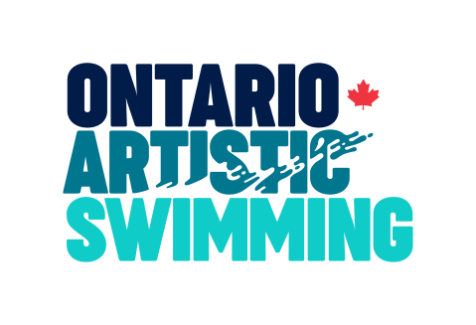

Rule Change Request Form
For a provincial rule change to be considered by the Ontario Artistic Swimming Rules Committee, an OAS Rule Change Request Form must be submitted by the specified deadline. Rule change requests may only be submitted by:
- Registered Ontario Artistic Swimming Officials
- Ontario Artistic Swimming Board Members and Staff
- Ontario Artistic Swimming member clubs (for which a proposal must be submitted jointly by the Club Head Coach and Club President)

Name(s):
OAS Membership:
Club (if applicable):
Date Submitted:
Rule Change Proposal: | [ ] Proposal for a change to a current rule  [ ] Proposal for a new rule
PART 1
Existing Rule Number and Text (if a new rule, write “new rule” in this space)

PART 2
Proposed Amendment(s) - additions to existing wording must be highlighted by underlining the new inserted text and deletions must be shown using strikethrough formatting.

PART 3
Rationale and Effective Date

Use additional sheets as required.
Please submit this form to Mary-Jane Ling via email (mjling@ontarioartisticswimming.ca) for consideration by the Rules Committee.

