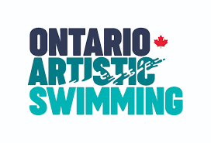

Ontario Coach Committee Statement of Interest

Submission Details: Statement of interest must be submitted by Sunday, October 3, 2021, at 11:00 pm EST, with the first meeting of the Committee taking place following selection. Submissions must be sent via email to coaches@ontarioartisticswimming.ca. Please see the Terms of Reference for this Committee.

Name:
Club Affiliation:
NCCP Certification:
2019-2021 Coaching Experience
(e.g., what level(s) have you coached? Recreational, Masters, CUASL, Novice, Provincial, National, High-Performance, Head Coach, Assistant Head Coach etc.)
Experience or Training in Equity, Diversity, and Inclusion (EDI)

Indicate, by highlighting the position you are seeking to fill:

- National and High-Performance Coach Representative
- Novice and Provincial Coach Representative
- Master or CUASL Coach Representative
- Recreational Coach Representative

Briefly describe your coaching experience (approximately 200 words):

Briefly describe your interest in serving on the Ontario Coach Committee (approximately 200 words):

