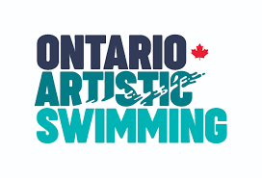

Ontario Athlete Advisory Council Statement of Interest

Submission Details: Statement of interest must be submitted by Sunday, October 3, 2021 at 11:00pm EST, with the first meeting of the Council taking place following selection. Submissions must be sent via email to athletes@ontarioartisticswimming.ca. Please see the Terms of Reference for this Council.

Name:
Club Affiliation:
2019-2021 Experience
(e.g., which level(s) have you competed? Recreational, Masters, CUASL, Novice, Provincial, National, High-Performance)

Indicate, by highlighting the position you are seeking to fill:

- National and High-Performance Athletes’ Representative
- Novice and Provincial Athletes’ Representative
- CUASL Athletes’ Representative
- Master Athletes’ Representative
- 13-15 Athletes’ Representative (Non-voting Members)
- Advisory members (Non-voting Members)

Briefly describe your experience as an athlete (approximately 200 words):

Do you have any previous leadership experience and/or Equity, Diversity, and Inclusion training? If so, please describe (approximately 200 words):

Briefly describe your interest in serving on the Ontario Athlete Advisory Council (approximately 200 words):

